# Predicting Failure of Shuttle O-Rings Using Machine Learning

# Philip Ross Oglesby

**Data Set Background**

The data set was acquired via the University of California at Irvine Machine Learning Repository, an extremely useful source for introductory Data Scientists who would like smaller data sets to get started in the field, but who lack “open” data from the entity they are associated with. The author was drawn to this data set having spent most of his career in aerospace manufacturing and seeing a large degree of potential in applying machine learning to many aspects of the aerospace design and manufacturing.

The motivation for the data set came from the Space Shuttle Challenger’s failure on January 28th, 1986. This has been come to known as one of the largest failures in aerospace history that ultimately lead to the death of seven crew members and the creation of the Rogers Commission to investigate the failure. Ultimately, it was determined that the failure of an O-Ring in the shuttle’s solid rocket motors. At the time of the launch, the ambient air temperature at Cape Canaveral was around 30 degrees Fahrenheit. This is thought to be the largest driver of O-Ring failure during the Challenger launch.

**Exploratory Data Analysis and Data Summary**

With the prevailing theory that ambient air temperature on the launch pad was a cause of the O-ring failure, it was decided to first look at the relationship between the ambient air temperature during the day of flight and the number of O-rings measured in distress from the data set as shown in Figure 1.

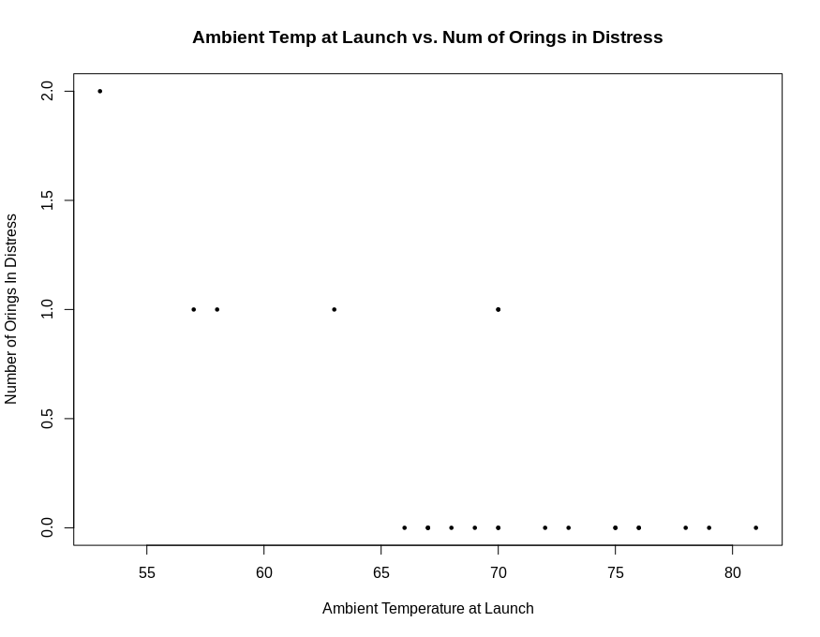

Figure 1: Ambient Temperature at Launch vs. Number of O-rings In Distress

A cursory analysis of Figure 1 shows that generally, at lower temperature at launch, the number of O-rings measured as “In Distress” increases. This would make temperature a great factor for predicting whether an O-ring may fail, or not. The next factor worth exploring in the data set would be the measured leak check pressure. A leak check is a common test done with many fluid vessels in order to determine their stability. The data set includes multiple levels of leak check pressure, none of which seem off-nominal as seen by the box plot from Figure 2. Still, it could be a factor driving failure. Figure 4 gives a plot of the the leak check PSI vs the number of O-rings in distress. There seems to be little correlation from a first visual look but details the wide ranges of pressures that the O-ring seals were tested over the 23 different flights in the data set.

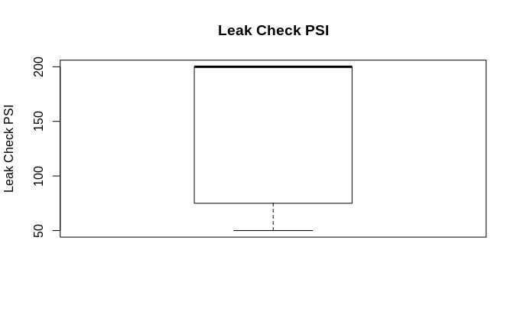 Figure 2: Overview of Leak Check Data

Figure 3 is a plot of the temperature at launch during a given day and shows the wide range of temperatures at Cape Canaveral over the 23 different launches observed in the data set. It should be noted that the lowest recorded temperature was 53 degrees Fahrenheit, while the Challenger explosion was around 30 degrees. Note from Figure 1 that distress on O-rings seemed to only be correlated with temperatures below 70 degrees F. This is leads the author to believe that a statistical approach to predicting O-ring failure would likely be focused around lower temperatures.

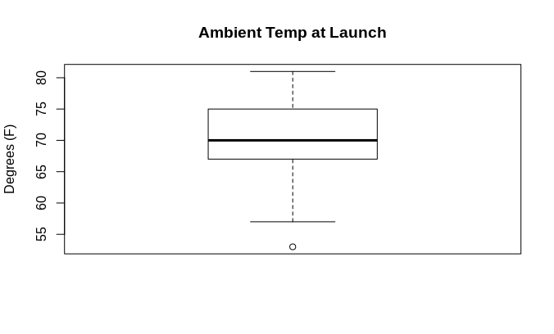

Figure 3: Ambient Temperature at Launch

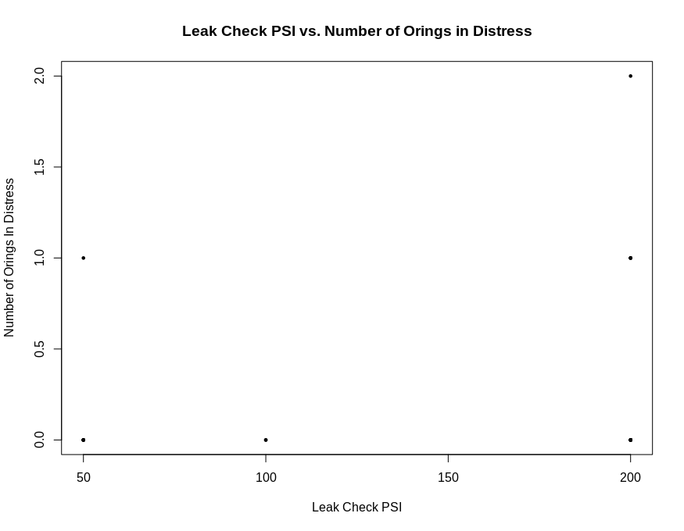Figure 4 (Leak Check PSI vs. Number of O-rings in Distress)

As Figure 4 shows, the leak check pressure has virtually the same number of O-rings in distress at both tested pressures. While much discussion about the engineering of the O-rings has largely cast off the idea that the leak check test had much to do with a distressed O-ring, much of the engineering literature for details beyond the scope of this paper have shown that the leak check test PSI is not a good predictor of O-ring distress.

Some simple statistical analysis is also extremely useful to get an idea of how the data might be interrelated. The statistical correlation between the number of distressed O-rings and the ambient temperature at launch is very negatively correlated given the data at -0.72. This is not surprising to the author, considering the prevailing theory is that the number of O-ring failures would rise as temperature would fall. In the case of leak check pressure vs. number of distressed O-rings, it seems that they are weakly positively correlated, with a value of 0.22. This reinforces the theory that leak check pressure is actually a relatively poor predictor of the number of O-rings in distress.

**Machine Learning Application**

Armed with some statistical analysis and a good idea of the data, supervised machine learning techniques were applied to get an idea of how to predict an O-ring failure. While more O-ring distress data at lower temperatures would have been more useful, the author will attempt to use a logistic regression to predict whether an O-ring will fail at a given temperature, likely a lower temperature given the Challenger failure was at a lower temperature than what was given in the data set; around 30 degrees Fahrenheit.

The author believed that a logistic regression model may be most useful for predicting whether an O-ring will fail or not at a given temperature. Noting that the relationship of number of O-ring’s in distress to temperature and leak check PSI, a logistic regression model can roughly be applied. After fitting a logistic regression model in R using launch temperature and leak check PSI as predictors, R reports that the p-value is higher than what would be extremely statistically significant for temperature and leak check PSI, 0.175 and 0.418 respectively. Still, the model may be somewhat useful for predicting distress on an O-ring.

Analyzing the output of the logistic regression model shows about a 78% accuracy rate of classifying a distressed O-ring based upon a small training data set of roughly 14 observations and a test set of 9 observations. This accuracy rate was surprisingly high given the low statistical significance of predictors given by R. It should be noted that the author considered a correct O-ring classification if the probability was above 50%. While the author would not consider this a conservative approach to measuring model accuracy, it does provide a good first step. Larger organizations such as NASA would likely employ a much more conservative approach for a large program such as the shuttle, requiring probabilities much lower than 50% to consider the prediction classified as a possible O-ring in distress.

**Next Steps and Further Thoughts**

While the author’s use of classification of O-ring failure felt reasonably successful, there are a few areas that the model could much more effectively be expanded. These includes the possible use of a multiple linear regression model to predict the number of O-rings that may fail versus classifying whether an O-ring will fail or not. Next, to improve the accuracy of the model, generating some random test data extrapolated from historical temperature data to fit the model more accurately and possibly raise the statistical significance of the temperature factor. This may add accuracy to the machine learning model and could be used for a logistic regression or multiple linear regression model.